

**Computer Networks**

**Company Name:**

***“****Futurenostics****”***

**Project Submission Report**

**Prepared By:**

|  |  |  |
| --- | --- | --- |
| Name | Roll Number | Email Address |
| Muhammad Ali | 241383 | 241383@students.au.edu.pk |
| Zain ul Abideen | 241475 | 241475@students.au.edu.pk |
| Ayesha Siddiqa | 241419 | 241419@students.au.edu.pk |

**Submitted To:**

Mam Amna Sarwar

Email: amna.sarwar@students.au.edu.pk

Table of Contents

1. Connectivity Testing 3

Intra-VLAN Connectivity Tests (Layer 2 Switching): 3

Inter-VLAN Connectivity Tests (Router Forwarding): 4

VLAN and Inter VLAN testing via PDU: 7

Cross-Branch Connectivity Tests ( OSPF, ACL): 7

OSPF testing: 8

HSRP Testing : 8

2.Firewall testing : 9

Zones: 9

NAT: 11

telnet timeout and ssh timeout : 11

3. IDS/IPS Detection Testing 11

Attack : ICMP Flood (Ping Storm) 12

Test 1 12

Test 2 12

Test 3: 12

IDS/IPS Summary: 12

4. Client Server Connectivity Tests 12

DHCP: 13

DNS: 13

WEB: 14

FTP: 15

Testing Report :

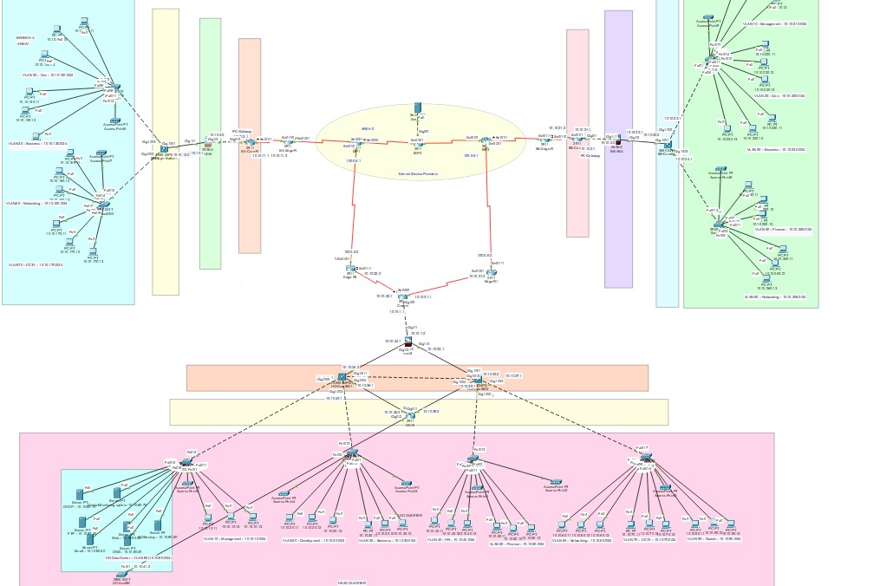

# 1. Connectivity Testing

## Intra-VLAN Connectivity Tests (Layer 2 Switching):

|  |  |  |  |  |
| --- | --- | --- | --- | --- |
| Test | Source | Destination | Latency | Status |
| VLAN 10 PC to VLAN 10 PC | 10.10.10.11 | 10.10.10.12 | <1ms | ✓ PASS |

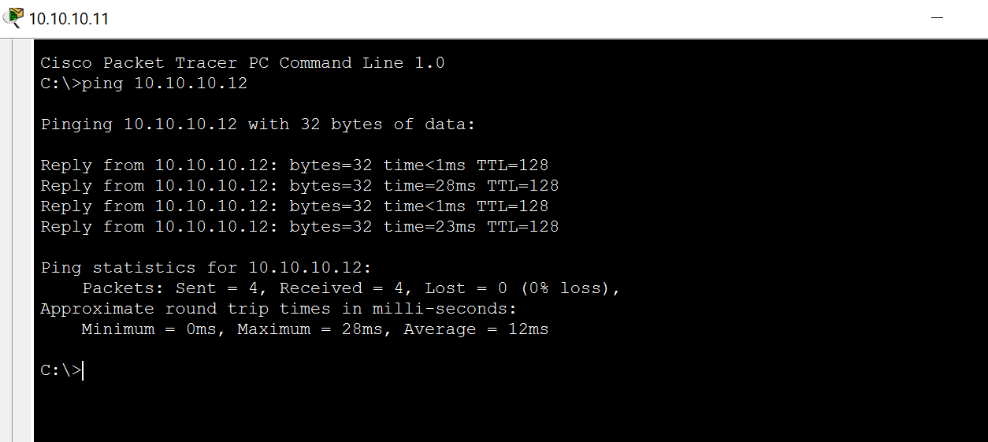

## Inter-VLAN Connectivity Tests (Router Forwarding):

|  |  |  |  |  |
| --- | --- | --- | --- | --- |
| Test | Source VLAN | Destination VLAN | Latency | Status |
| Management to Development | VLAN 10 | VLAN 20 | <1ms | ✓ PASS |
| Business to Servers | VLAN 30 | VLAN 80 | <1ms | ✓ PASS |
| Development to Business | VLAN 20 | VLAN 30 | <1ms | ✓ PASS |
| Management to Servers | VLAN10 | VLAN 80 | <1ms | ✓ PASS |
| Development to Finance | VLAN 20 | VLAN 50 | <1ms | ✓ PASS |

Management to Development:

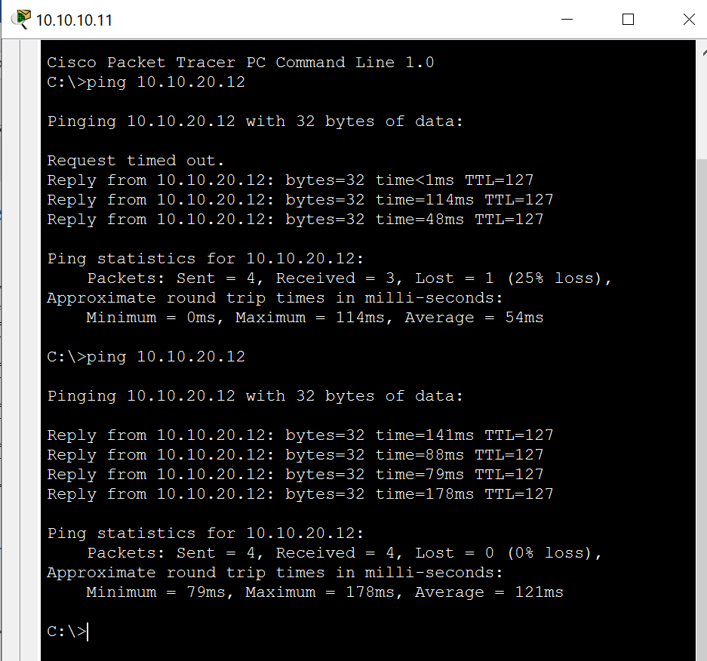

Business to Servers :

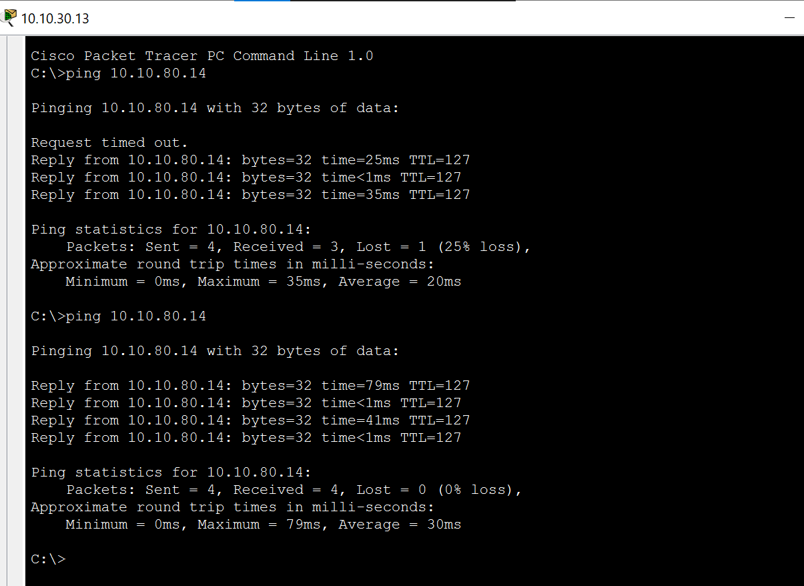

Bussiness to Development :

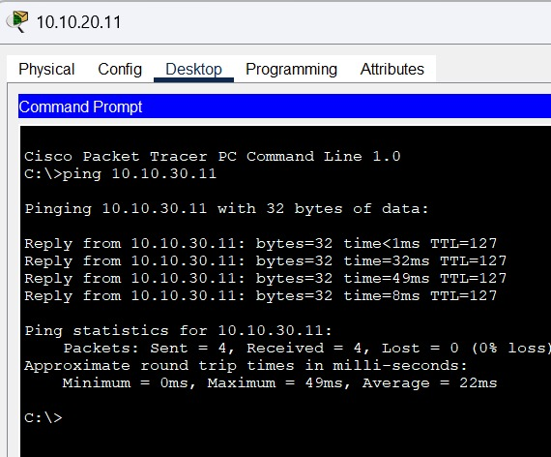

Management to servers:

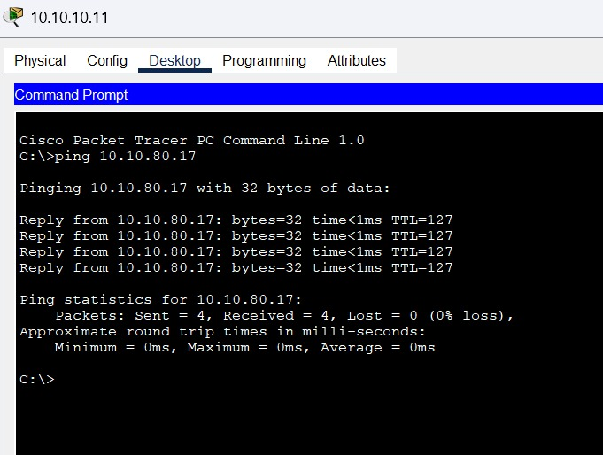

Development to Finance:

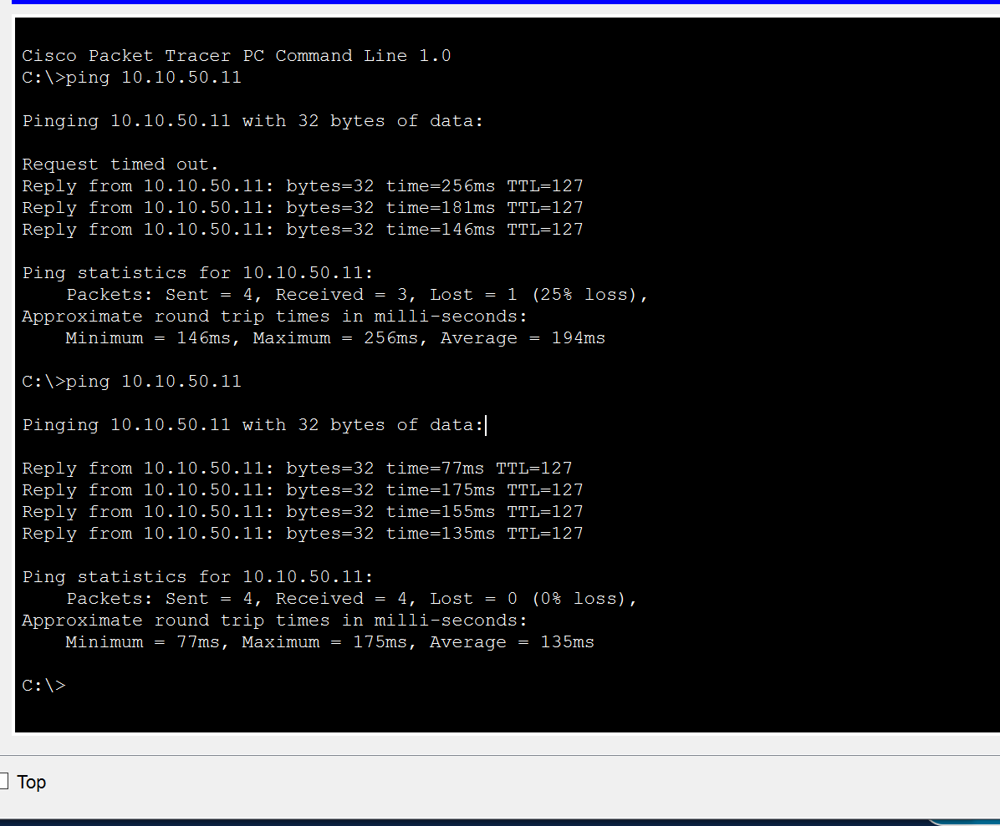

S

## VLAN and Inter VLAN testing via PDU:

Deveoplment to Bussiness :

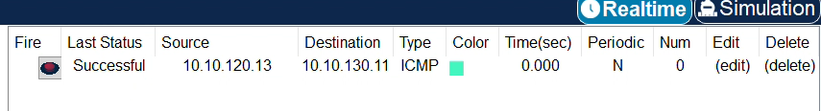

Networking to Bussiness:



## Cross-Branch Connectivity Tests ( OSPF, ACL):

ACL Rules:

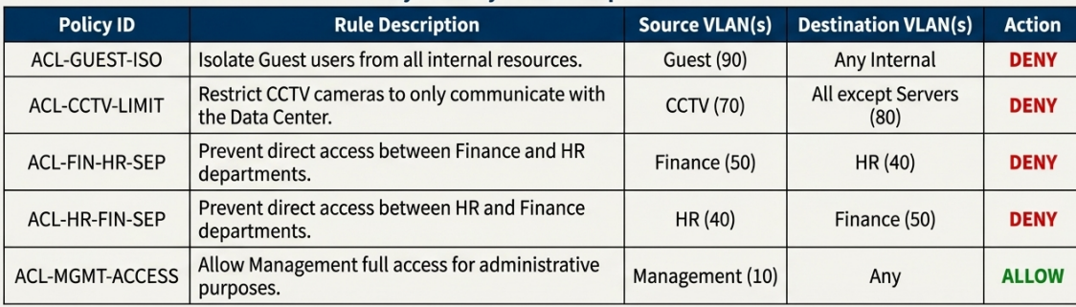

Testing:

|  |  |  |  |  |  |
| --- | --- | --- | --- | --- | --- |
| Path | Source | Destination | Latency | Packet Loss | Status |
| HQ to BA | VLAN 10 (HQ) | VLAN 20 (BA) | <1ms | 2% | ✓ PASS |
| HQ to BB | VLAN 20 (HQ) | VLAN 30 (BB) | ~1ms | 0% | ✓ PASS |
| BA to BB | VLAN 20 (BA) | VLAN 20 (BB) | 2ms | 3% | ✓ PASS |
| BA to HQ Servers | VLAN 30 (BA) | VLAN 80 (HQ) | <1ms | 4% | ✓ PASS |

### OSPF testing:

OSPF Areas

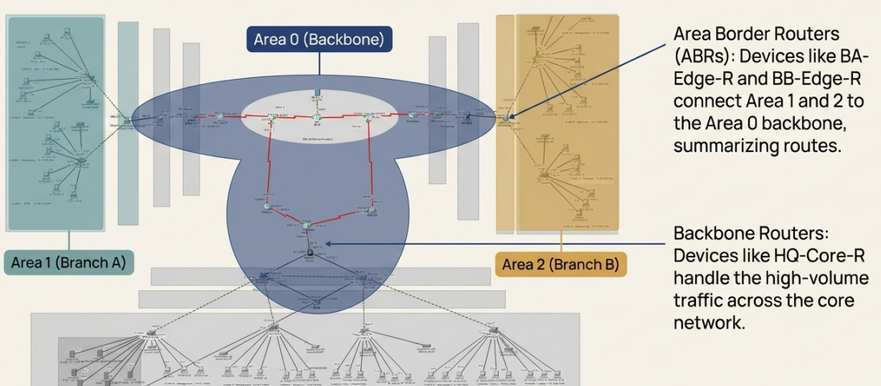

Branch B:

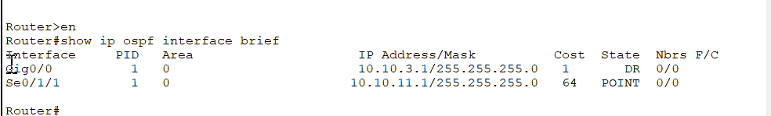

HQ:

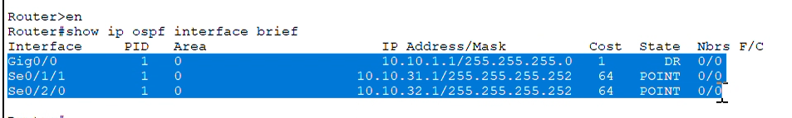

### HSRP Testing :

Head Quarter :

Switch 1: 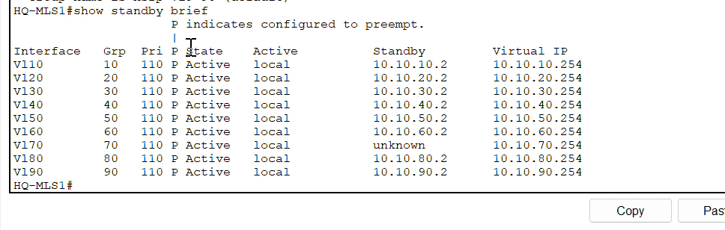

Switch 2:

This second one is on stand by: 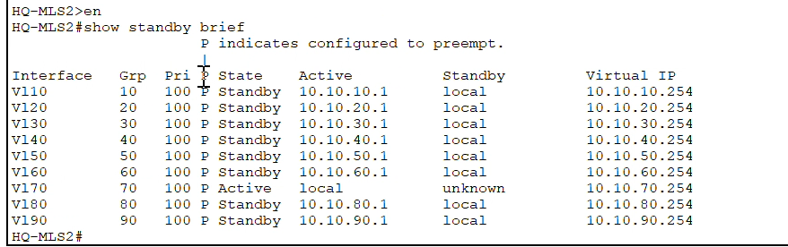

# 2.Firewall testing :

## Zones:

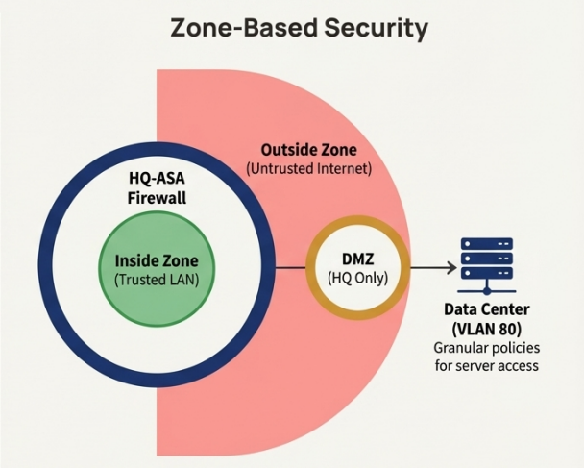

Outside , Inside , DMZ

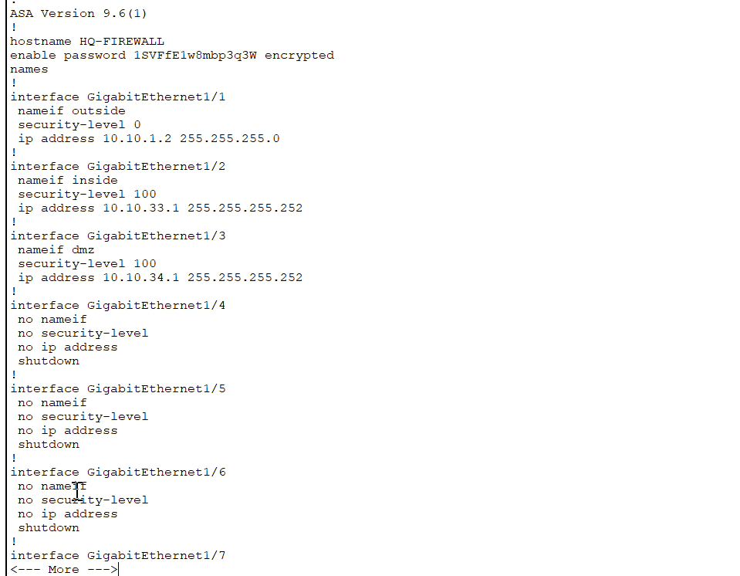

## NAT:

v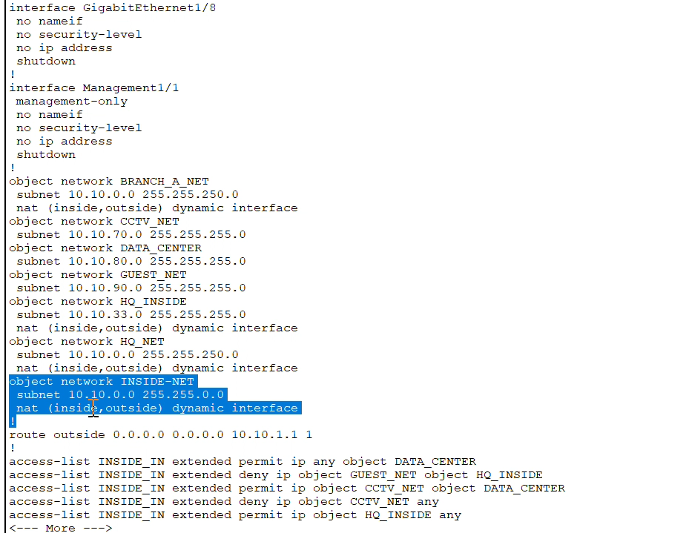

## telnet timeout and ssh timeout :

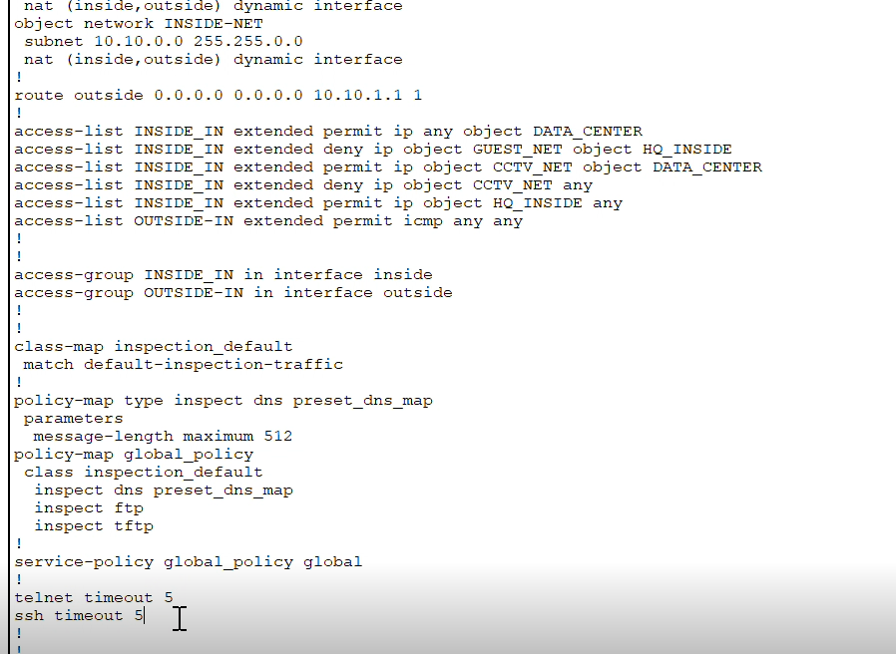

# 3. IDS/IPS Detection Testing

Attack Detection Scenarios Implemented:

## Attack : ICMP Flood (Ping Storm)

### Test 1

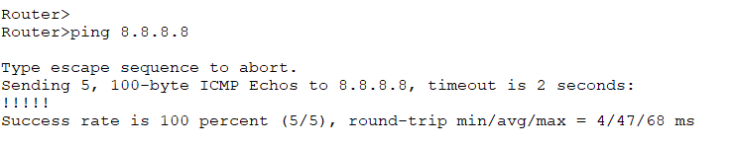

### Test 2

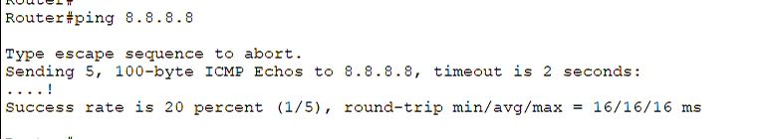

### Test 3:

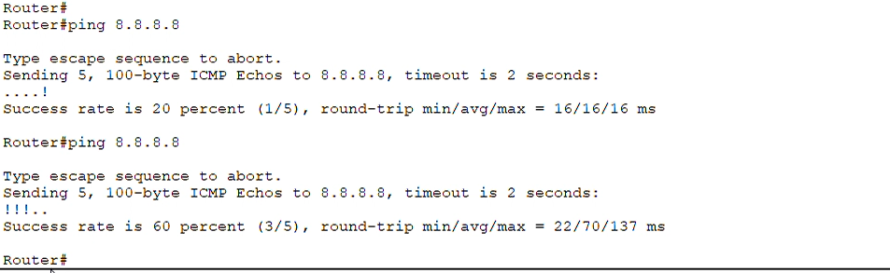

While trying to access internet server via branch routers

## IDS/IPS Summary:

|  |  |  |  |
| --- | --- | --- | --- |
| Attack Type | Detection Method | Alert Level | Response Action |
| ICMP Flood | Threshold crossing | MEDIUM | Throttle ICMP traffic |

# 4. Client Server Connectivity Tests

|  |  |  |  |  |
| --- | --- | --- | --- | --- |
| Test Case | Client VLAN | Service | Result | Status |
| DHCP Assignment | VLAN 20 | DHCP Server | Dhcp pool ip | ✓ PASS |
| DNS Resolution | VLAN 10 | DNS Server | futurenostic website | ✓ PASS |
| Web Portal Access | VLAN 30 | HTTP 80 | futurenostic website | ✓ PASS |
| FTP Access | VLAN 20 | FTP 21 | Successfully uploaded and downloaded files from and to server | ✓ PASS |

## DHCP:

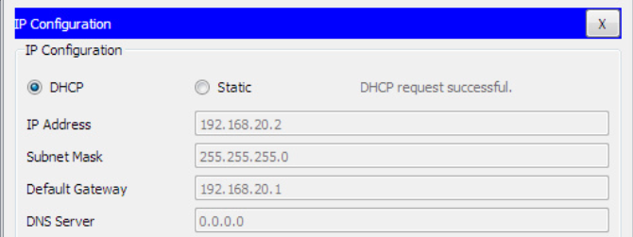

## DNS:



## WEB:



Services section :

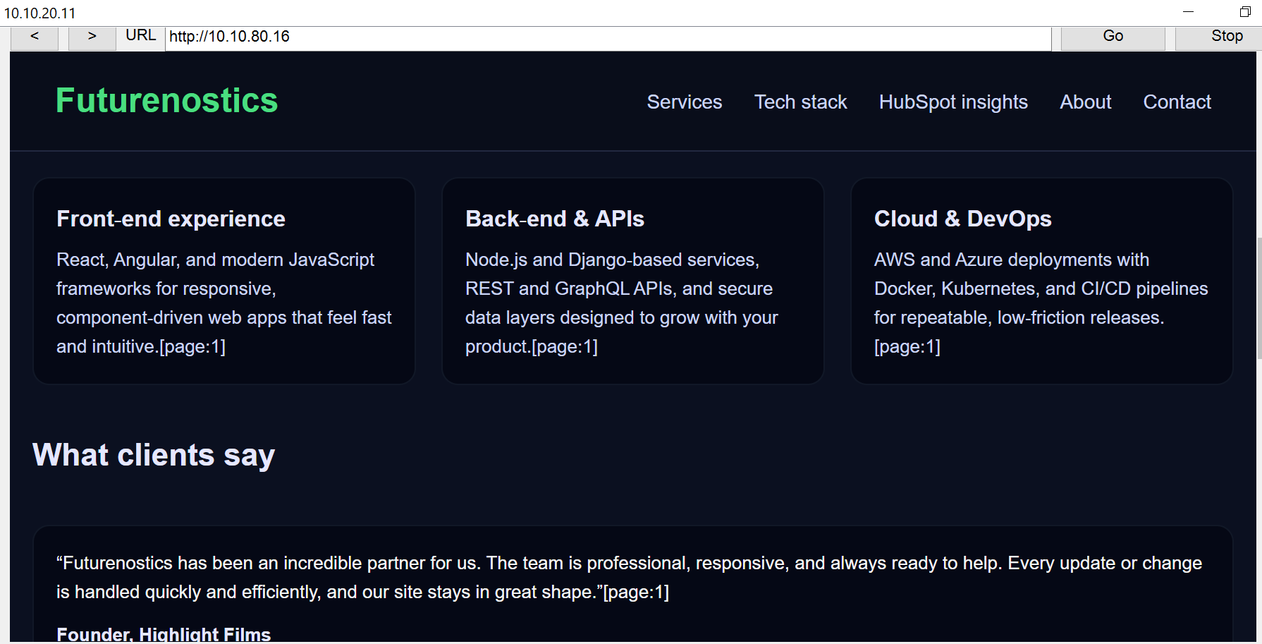

And so on

## FTP:

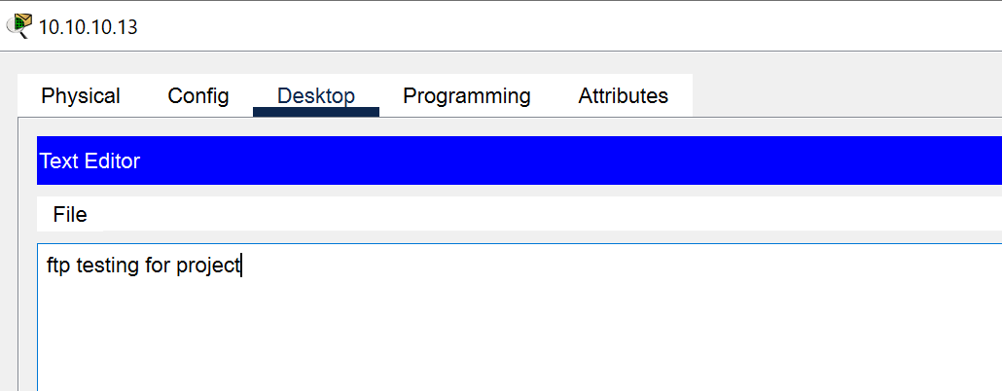

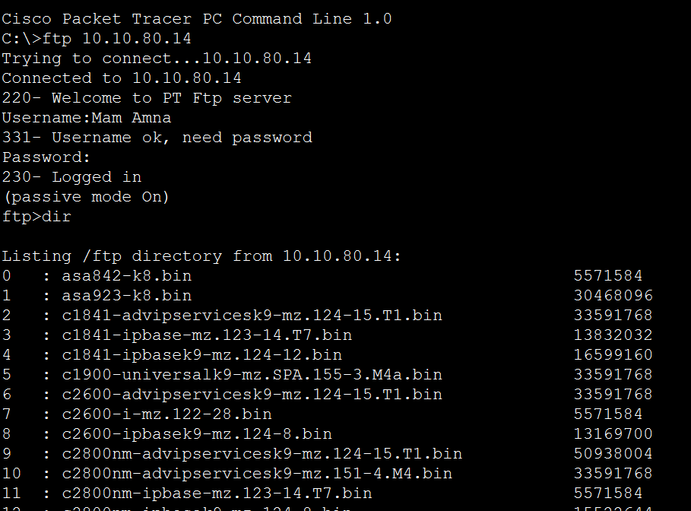

For [ftp.txt](ftp://ftp.txt):

Uploaded and downloaded for from server with following commands:

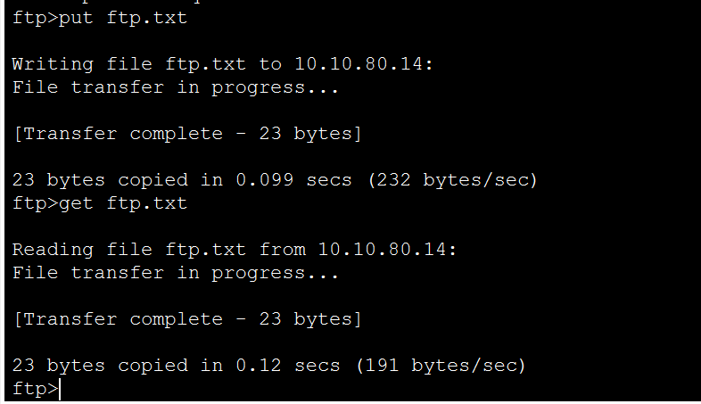

NOW IN THIS WAY EVERYHTING IS TESTED AND NETWORK IS READY:

